**I Revolution: A Data-Driven Exploration of Apple's IPhone Impact in India**

**Introduction:**

The world has changed as a consequence of the increasing use of smartphones, which have improved communication, connected people, and revolutionized many different businesses. With its main product, the iPhone, capturing markets around the world, Apple Inc. has emerged as a prominent player among the top smartphone makers. India, one of the economies with the greatest economic growth, has seen a tremendous increase in smartphone usage, making it an interesting market to study the effects of Apple's iPhone.

Apple has a special chance to increase its market share and develop a significant presence in India thanks to the country's large population and rising smartphone adoption. Each new iPhone model unveiling generates excitement and anticipation among Indian buyers. This research aims to go beyond conjecture and anecdotal evidence in order to develop a thorough knowledge of the effects of the iPhone.

**Purpose:**

The purpose of this study is to obtain a thorough understanding of how Apple's iPhone would affect the Indian market. In particular, we want to investigate the market penetration of iPhones in India, comprehend consumer preferences and decision-making processes, and assess the social and economic effects of iPhone adoption. We aim to offer insights that can direct strategic decisions for Apple and other stakeholders active in the Indian smartphone industry by leveraging data analytics and visualizations using Tableau.

**Conclusion & Future Scope:**

An important scope of this study is the societal impact of Apple's iPhone in India. We intend to investigate how the iPhone has altered communication, information access, and social relationships in Indian society through data analytics and Tableau visualizations. Studying the impact of iPhones on social media use, online content consumption, and the broader digital divide are all included in this. Policymakers and organizations can better manage the benefits and difficulties brought on by the expanding smartphone adoption by understanding the social impact.

Research must focus on how Apple's iPhone has affected business in India. We seek to examine the economic effects of iPhone uptake in the Indian market using data analytics and Tableau visualizations. Organizations can find possibilities for growth and innovation by understanding the business impact and using it to help them position themselves in their markets and make strategic decisions.

### Screenshot of Brainstorming Map:

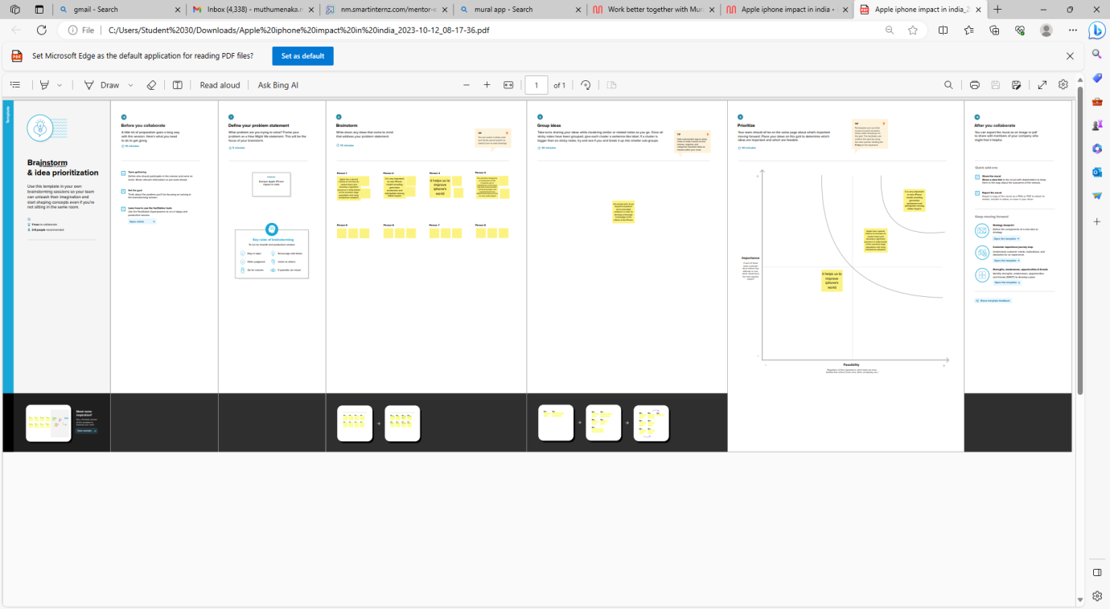

### Screenshot of Empathy Map:

### C:\Users\Student 30\Videos\Captures\Apple Iphone Project_2023-10-12_08-20-47.pdf and 6 more pages - Personal - Microsoft​ Edge 12-10-2023 13_51_21.png